

1 طريقه تركيب blugin بلجن كويس كا منيو لعرض الامنتجات الى فى الاقسام

تمام تعالى نستخدم ال plugin دى

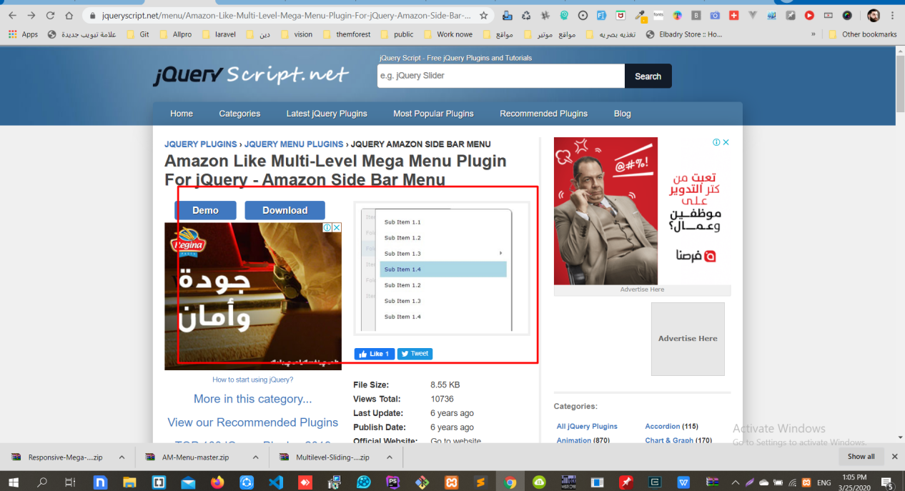

وده لينكها

<https://www.jqueryscript.net/menu/Amazon-Like-Multi-Level-Mega-Menu-Plugin-For-jQuery-Amazon-Side-Bar-Menu.html>

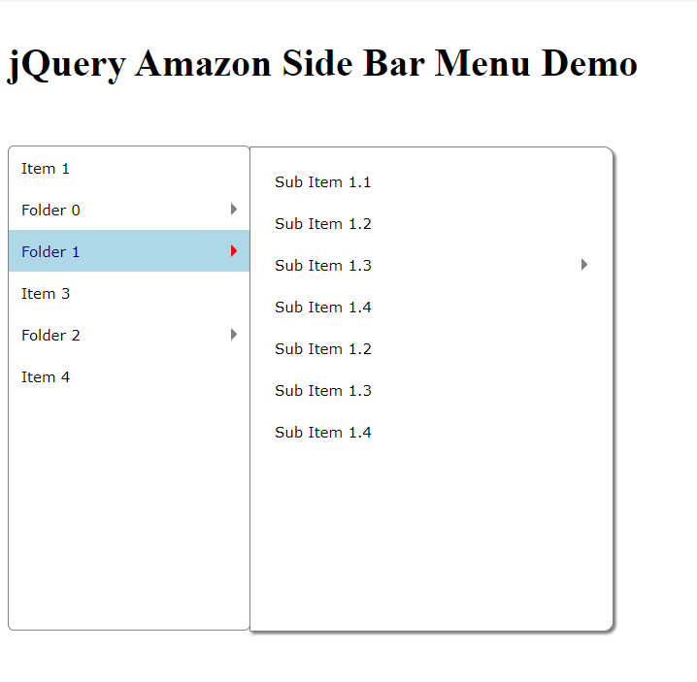

اول حاجه هتاخد الhtml

الى هو ده

{{-- ---------------------------------------------}}  
 <nav id="mysidebarmenu" class="amazonmenu">  
 <ul>  
 <li><a href="#">Item 1</a></li>  
 <li><a href="#">Folder 0</a>  
 <div>  
 <p>Browse our spring collection of useful webmaster tools and resources! Everything from JavaScript, CSS to PHP are covered!</p>  
  
 <ul>  
 <li><a href="#">JavaScript Kit</a></li>  
 <li><a href="#">CSS Drive</a></li>  
 <li><a href="#">CSS Library</a>  
 <li><a href="#">Webmaster Tools</a>  
 <div>  
 <p><h3><a href="#">Image Optimizer</a></h3>  
 Use this tool to easily optimize regular gifs, animated gifs, jpgs, and pngs, so they load as fast as possible.  
 </p>  
  
 <p><h3><a href="#">FavIcon Generator</a></h3>  
 Generate a favicon using any regular image with this tool.  
 </p>  
  
 <p><h3><a href="#">Animated Gif Generator</a></h3>  
 Animated Gif Generator lets you easily create an animated gif by uploading a series of still images!  
 </p>  
  
 </div>  
  
 <li><a href="#">PHP For the Absolute Beginner</a></li>  
 </ul>  
 </div>  
 </li>  
 <li><a href="#">Folder 1</a>  
 <ul>  
 <li><a href="#">Sub Item 1.1</a></li>  
 <li><a href="#">Sub Item 1.2</a></li>  
 <li><a href="#">Sub Item 1.3</a>  
 <ul>  
 <li>Sub Item 1.3.1</li>  
 <li>Sub Item 1.3.2</li>  
 <li>Sub Item 1.3.3</li>  
 </ul>  
 </li>  
 <li><a href="#">Sub Item 1.4</a></li>  
 <li><a href="#">Sub Item 1.2</a></li>  
 <li><a href="#">Sub Item 1.3</a></li>  
 <li><a href="#">Sub Item 1.4</a></li>  
 </ul>  
 </li>  
 <li><a href="#">Item 3</a></li>  
 <li><a href="#">Folder 2</a>  
 <ul>  
 <li><a href="#">Sub Item 2.1</a></li>  
 <li><a href="#">Sub Item 2.1</a></li>  
 <li><a href="#">Sub Item 2.1</a></li>  
 <li><a href="#">Sub Item 2.1</a></li>  
 <li><a href="#">Sub Item 2.1</a></li>  
 <li><a href="#">Sub Item 2.1</a></li>  
 </ul>  
 </li>  
 <li><a href="#">Item 4</a></li>  
 </ul>  
 </nav>  
  
{{-- ---------------------------------------------}}

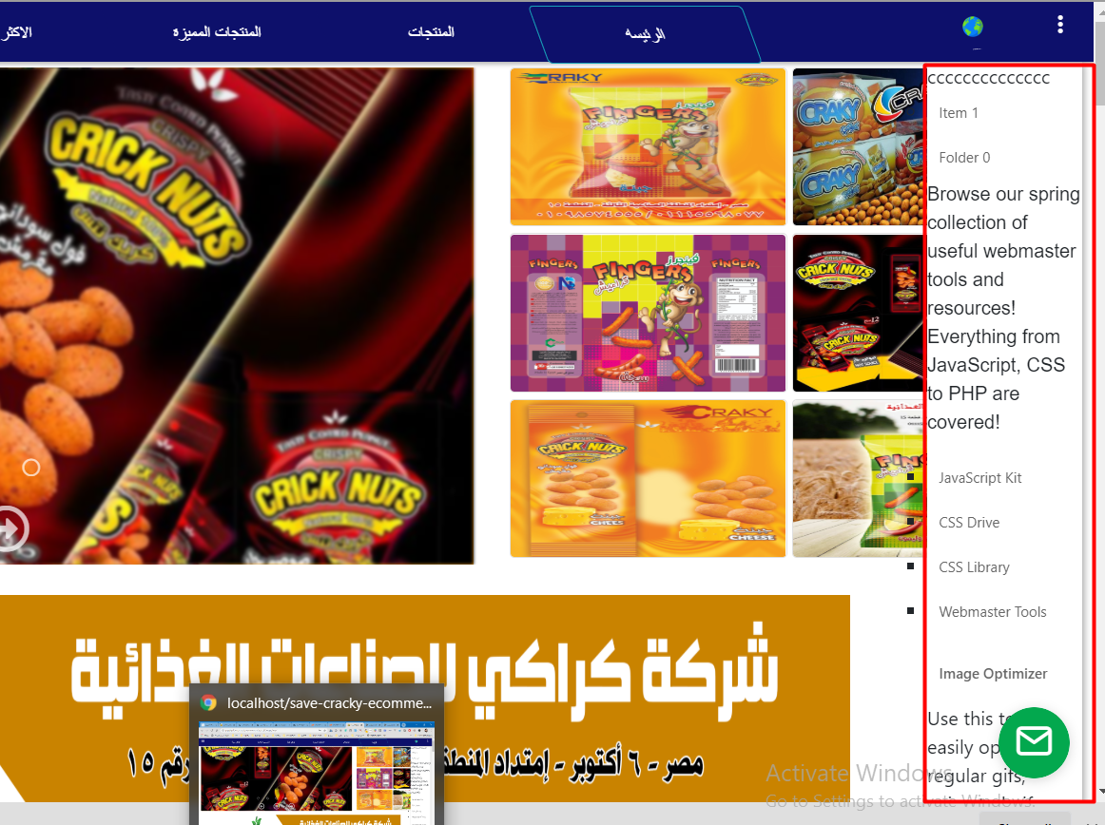

اول حاجه هتعمل من الinspect elment hover

وبعد كده تروح على الhader وتضيف الملفات فيه

<!--start menue Amazang ---------------------------------------------------- -->  
 <link rel="stylesheet" type="text/css" href="{{url('front')}}/layout/Amazon-Side-Bar-Menu-Multi-Level-Mega/amazonmenu.css">  
 <link href="http://www.jqueryscript.net/css/jquerysctipttop.css" rel="stylesheet" type="text/css">  
 <!--<script src="http://ajax.googleapis.com/ajax/libs/jquery/1.11.0/jquery.min.js"></script>-->  
  
 <script src="{{url('front')}}/layout/Amazon-Side-Bar-Menu-Multi-Level-Mega/amazonmenu.js">  
 /* =====================================  
 ** Amazon Side Bar Menu- by JavaScript Kit (www.javascriptkit.com)  
 ** Visit JavaScript Kit at # for full source code  
 ===================================== */  
  
 </script>  
  
  
 <script>  
  
 jQuery(function(){  
 ***amazonmenu***.init({  
 menuid: 'mysidebarmenu'  
 })  
 })  
  
 </script>  
   
 <script type="text/javascript">  
 <!--  
 google_ad_client = "ca-pub-2783044520727903";  
 /* jQuery_demo */  
 google_ad_slot = "2780937993";  
 google_ad_width = 728;  
 google_ad_height = 90;  
 //-->  
 </script>  
 <script type="text/javascript"  
 src="http://pagead2.googlesyndication.com/pagead/show_ads.js">  
 </script>  
   
  
 <script type="text/javascript">  
  
 var _gaq = ***_gaq*** || [];  
 _gaq.push(['_setAccount', 'UA-36251023-1']);  
 _gaq.push(['_setDomainName', 'jqueryscript.net']);  
 _gaq.push(['_trackPageview']);  
  
 (function() {  
 var ga = ***document***.createElement('script'); ga.type = 'text/javascript'; ga.async = true;  
 ga.src = ('https:' == ***document***.location.protocol ? 'https://ssl' : 'http://www') + '.google-analytics.com/ga.js';  
 var s = ***document***.getElementsByTagName('script')[0]; s.parentNode.insertBefore(ga, s);  
 })();  
  
 </script>  
  
<!--ُEnd -----------------------amazonmenu ----------------------------------------- -->

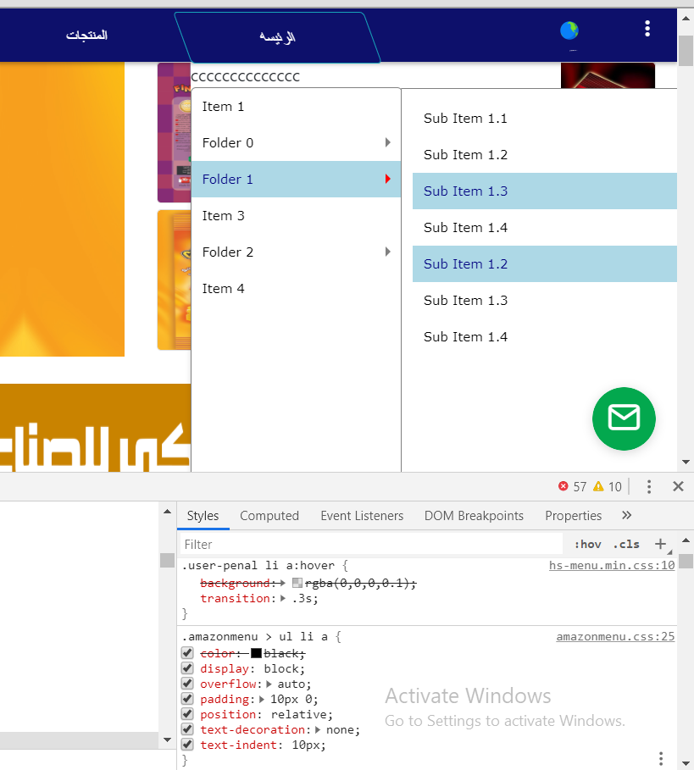

طبعا وده تنسيق من عنددى عشان نغير اتجهه

<style>  
 .user-penal {  
 width: 17%;  
 box-shadow: 2px 2px 6px rgba(0,0,0,0.33);  
 background: #fff;  
 list-style: none;  
 position: fixed;  
 display: none;  
 top: 50px;  
 right: -56px;  
 line-height: 1.5;  
 z-index: 100;  
 }  
 .amazonmenu > ul li.hassub > a::after {  
 border: 5px solid transparent;  
 border-left-color: gray;  
 content: '';  
 height: 0;  
 position: absolute;  
 left: -3px;  
 top: 35%;  
 width: 0;  
 transform: rotate(180deg);  
 }  
 .amazonmenu ul li {  
 position: static;  
 text-align: right;  
 padding-right: 10px;  
 }  
 .amazonmenu ul li > div, .amazonmenu ul li > ul {  
 background: white;  
 border: 1px solid gray;  
 border-radius: 0 8px 8px 0;  
 box-shadow: 2px 2px 2px grey;  
 display: none;  
 font-weight: normal;  
 width: 300px;  
 height: 400px;  
 padding: 10px;  
 position: absolute;  
 top: 0;  
 -webkit-box-sizing: border-box;  
 -moz-box-sizing: border-box;  
 box-sizing: border-box;  
 z-index: 1000;  
 left: -152% **!important**;  
 }  
  
  
</style>

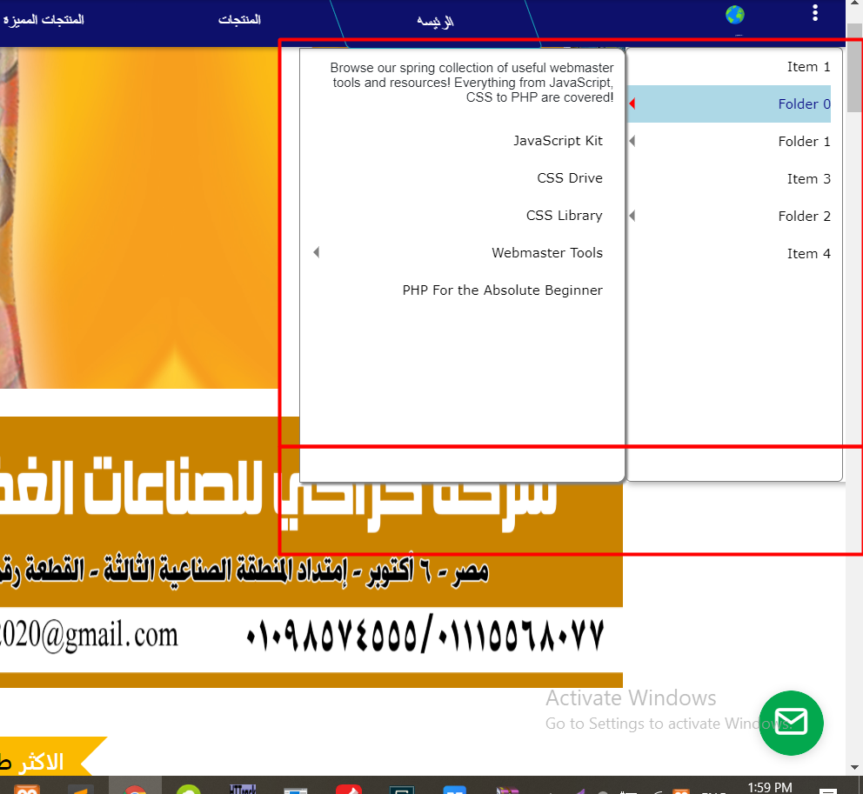

تمام كده كا تصميم اشطه جداااااااااااااااااااااااااااااااااااا

.............................................

فاضل بقا نبرمجها ونقلو اعرضلنا اسماء الاقسام وداخل كل وحده المنتجات بتعتها نفس فكره ال sidbarmenue

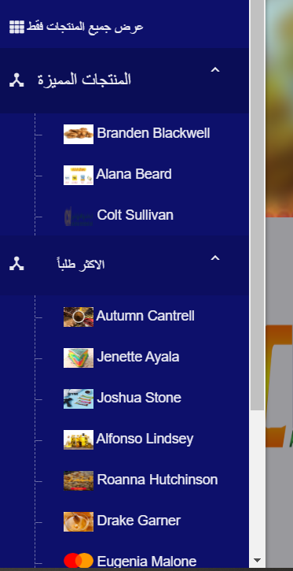

اول حاجه هاشتغل على عناصر واحد وهو هيكرار نفسه

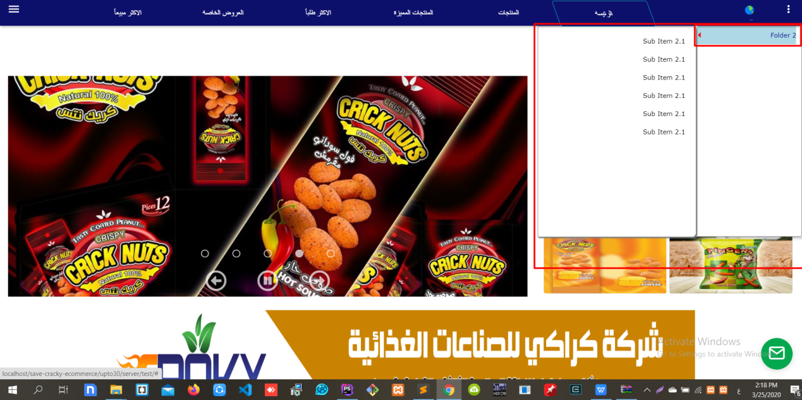

وبعد كده تدى التنسيقات الى انت عايزها

تمام ركبنها بى الشكل ده :)



وده الكود البرمجى بتعها

<!-- --------------------------------------- start session ar---------------------------------------- -->  
<section class="box-model">  
 <ul class="user-penal">  
 <li class=" ">  
 <nav id="mysidebarmenu" class="amazonmenu">  
 <ul>  
 @foreach($departments as $department)  
  
 {{-- start dep id 13----------------------------------------------}}  
 @if($department->id == '13')  
 <li>  
 <a href="{{url('show/department/13')}}">  
 {{trans('admin.Latest_product')}}  
 <!--................-->  
 @if(!empty($department->icon))  
 <img src="{{url('public/storage').'/'.$department->icon}} {{$department->photo}}"class="img_dpe_amazing_menue">  
 @else  
 <img class="" src="{{url('default')}}/dep.png" class="img_dpe_amazing_menue" >  
 @endif <!--End if department->icon-->  
 <!--................-->  
  
 </a>  
 <ul>  
 <li>  
 <a href="show/department/19">  
 @foreach($products as $product)  
 @if($department->id == $product->department_id)  
 <li>  
 <a href="{{url('show/product/'.$product->id)}}">  
 <span>{{$product['product_name_'.$lang]}}</span>  
 <img class="w_30_hpx_20px" src="{{url('public/storage').'/'.$product->photo}}">  
  
 </a>  
 </li>  
 @endif  
 @endforeach <!-- End products -->  
 </a>  
 </li>  
 </ul>  
 </li>  
 @endif <!--End if department->id 13 -->  
 {{-- End dep id 13----------------------------------------------}}  
 {{-- start dep id 18----------------------------------------------}}  
 @if($department->id == '18')  
 <li>  
 <a href="{{url('show/department/18')}}">  
 {{trans('admin.featured_products')}}  
 <!--................-->  
 @if(!empty($department->icon))  
 <img src="{{url('public/storage').'/'.$department->icon}} {{$department->photo}}"class="img_dpe_amazing_menue">  
 @else  
 <img class="" src="{{url('default')}}/dep.png" class="img_dpe_amazing_menue" >  
 @endif <!--End if department->icon-->  
 <!--................-->  
  
 </a>  
 <ul>  
 <li>  
 <a href="show/department/18">  
 @foreach($products as $product)  
 @if($department->id == $product->department_id)  
 <li>  
 <a href="{{url('show/product/'.$product->id)}}">  
 <span>{{$product['product_name_'.$lang]}}</span>  
 <img class="w_30_hpx_20px" src="{{url('public/storage').'/'.$product->photo}}">  
 </a>  
 </li>  
 @endif  
 @endforeach <!-- End products -->  
 </a>  
 </li>  
 </ul>  
 </li>  
 @endif <!--End if department->id 18 -->  
 {{-- End dep id 18----------------------------------------------}}  
 {{-- start dep id 19----------------------------------------------}}  
 @if($department->id == '19')  
 <li>  
 <a href="{{url('show/department/19')}}">  
 {{trans('admin.the_most_wanted')}}  
 <!--................-->  
 @if(!empty($department->icon))  
 <img src="{{url('public/storage').'/'.$department->icon}} {{$department->photo}}"class="img_dpe_amazing_menue">  
 @else  
 <img class="" src="{{url('default')}}/dep.png" class="img_dpe_amazing_menue" >  
 @endif <!--End if department->icon-->  
 <!--................-->  
  
 </a>  
 <ul>  
 <li>  
 <a href="show/department/19">  
 @foreach($products as $product)  
 @if($department->id == $product->department_id)  
 <li>  
 <a href="{{url('show/product/'.$product->id)}}">  
 <span>{{$product['product_name_'.$lang]}}</span>  
 <img class="w_30_hpx_20px" src="{{url('public/storage').'/'.$product->photo}}">  
 </a>  
 </li>  
 @endif  
 @endforeach <!-- End products -->  
 </a>  
 </li>  
 </ul>  
 </li>  
 @endif <!--End if department->id 19 -->  
 {{-- End dep id 19----------------------------------------------}}  
 {{-- start dep id 20----------------------------------------------}}  
 @if($department->id == '20')  
 <li>  
 <a href="{{url('show/department/20')}}">  
 {{trans('admin.special_offers')}}  
 <!--................-->  
 @if(!empty($department->icon))  
 <img src="{{url('public/storage').'/'.$department->icon}} {{$department->photo}}"class="img_dpe_amazing_menue">  
 @else  
 <img class="" src="{{url('default')}}/dep.png" class="img_dpe_amazing_menue" >  
 @endif <!--End if department->icon-->  
 <!--................-->  
  
 </a>  
 <ul>  
 <li>  
 <a href="show/department/20">  
 @foreach($products as $product)  
 @if($department->id == $product->department_id)  
 <li>  
 <a href="{{url('show/product/'.$product->id)}}">  
 <span>{{$product['product_name_'.$lang]}}</span>  
 <img class="w_30_hpx_20px" src="{{url('public/storage').'/'.$product->photo}}">  
  
 </a>  
 </li>  
 @endif  
 @endforeach <!-- End products -->  
 </a>  
 </li>  
 </ul>  
 </li>  
 @endif <!--End if department->id 20 -->  
 {{-- End dep id 20----------------------------------------------}}  
 {{-- start dep id 21----------------------------------------------}}  
 @if($department->id == '21')  
 <li>  
 <a href="{{url('show/department/21')}}">  
 {{trans('admin.best_seller')}}  
 <!--................-->  
 @if(!empty($department->icon))  
 <img src="{{url('public/storage').'/'.$department->icon}} {{$department->photo}}"class="img_dpe_amazing_menue">  
 @else  
 <img class="" src="{{url('default')}}/dep.png" class="img_dpe_amazing_menue" >  
 @endif <!--End if department->icon-->  
 <!--................-->  
  
 </a>  
 <ul>  
 <li>  
 <a href="show/department/21">  
 @foreach($products as $product)  
 @if($department->id == $product->department_id)  
 <li>  
 <a href="{{url('show/product/'.$product->id)}}">  
 <span> {{$product['product_name_'.$lang]}}</span>  
 <img class="w_30_hpx_20px" src="{{url('public/storage').'/'.$product->photo}}">  
 </a>  
 </li>  
 @endif  
 @endforeach <!-- End products -->  
 </a>  
 </li>  
 </ul>  
 </li>  
 @endif <!--End if department->id 21 -->  
 {{-- End dep id 21----------------------------------------------}}  
  
 @endforeach <!-- End departments-->  
  
  
  
  
  
 </ul>  
 </nav>  
  
 {{-- ---------------------------------------------}}  
 </li >  
 <div class="d-none">  
 <li >  
 <a href="{{aurl('')}}"><i class="fas fa-eye"></i> admin </a>  
 </li >  
 @foreach($departments as $department)  
 @if($department->id == '18')  
 <li> <a href="#1" >  
 <!--................-->  
 @if(!empty($department->photo))  
 <img src="{{url('storage').'/'.$department->icon}} {{$department->photo}}"class="img_dpe_amazing_menue">  
 @else  
 <img class="" src="{{url('default')}}/dep.png" class="w_h_px" style="width: 20px;height: 20px;" >  
 @endif  
 <!--................-->  
 {{trans('admin.featured_products')}}  
 @endif  
  
 @if($department->id == '19')  
 <li> <a href="#1" >  
 <!--................-->  
 @if(!empty($department->photo))  
 <img src="{{url('storage').'/'.$department->icon}} {{$department->photo}}"style="width: 20px;height: 20px;">  
 @else  
 <img class="" src="{{url('default')}}/dep.png" class="w_h_px" style="width: 20px;height: 20px;" >  
 @endif  
 <!--................-->  
 {{trans('admin.the_most_wanted')}}  
 @endif  
  
 @if($department->id == '20')  
 <li> <a href="#1" >  
  
 <!--................-->  
 @if(!empty($department->photo))  
 <img src="{{url('storage').'/'.$department->icon}} {{$department->photo}}"style="width: 20px;height: 20px;">  
 @else  
 <img class="" src="{{url('default')}}/dep.png" class="w_h_px" style="width: 20px;height: 20px;" >  
 @endif  
 <!--................-->  
 {{trans('admin.special_offers')}}  
 @endif  
 @if($department->id == '21')  
 <li> <a href="#1" >  
 <!--................-->  
 @if(!empty($department->photo))  
 <img src="{{url('storage').'/'.$department->icon}} {{$department->photo}}"style="width: 20px;height: 20px;">  
 @else  
 <img class="" src="{{url('default')}}/dep.png" class="w_h_px" style="width: 20px;height: 20px;" >  
 @endif  
 <!--................-->  
 {{trans('admin.best_seller')}}  
 @endif  
 </a> </li>  
 @endforeach  
 </div>  
  
 </ul>  
  
</section>

وده ال style كود كااااااااااااامل

<!--start menue Amazang ---------------------------------------------------- -->  
 <link rel="stylesheet" type="text/css" href="{{url('front')}}/layout/Amazon-Side-Bar-Menu-Multi-Level-Mega/amazonmenu.css">  
 <link href="http://www.jqueryscript.net/css/jquerysctipttop.css" rel="stylesheet" type="text/css">  
 <!--<script src="http://ajax.googleapis.com/ajax/libs/jquery/1.11.0/jquery.min.js"></script>-->  
  
 <script src="{{url('front')}}/layout/Amazon-Side-Bar-Menu-Multi-Level-Mega/amazonmenu.js">  
 /* =====================================  
 ** Amazon Side Bar Menu- by JavaScript Kit (www.javascriptkit.com)  
 ** Visit JavaScript Kit at # for full source code  
 ===================================== */  
  
 </script>  
  
  
 <script>  
  
 jQuery(function(){  
 ***amazonmenu***.init({  
 menuid: 'mysidebarmenu'  
 })  
 })  
  
 </script>  
  
 <script type="text/javascript">  
 <!--  
 google_ad_client = "ca-pub-2783044520727903";  
 /* jQuery_demo */  
 google_ad_slot = "2780937993";  
 google_ad_width = 728;  
 google_ad_height = 90;  
 //-->  
 </script>  
 <script type="text/javascript"  
 src="http://pagead2.googlesyndication.com/pagead/show_ads.js">  
 </script>  
  
  
 <script type="text/javascript">  
  
 var _gaq = ***_gaq*** || [];  
 _gaq.push(['_setAccount', 'UA-36251023-1']);  
 _gaq.push(['_setDomainName', 'jqueryscript.net']);  
 _gaq.push(['_trackPageview']);  
  
 (function() {  
 var ga = ***document***.createElement('script'); ga.type = 'text/javascript'; ga.async = true;  
 ga.src = ('https:' == ***document***.location.protocol ? 'https://ssl' : 'http://www') + '.google-analytics.com/ga.js';  
 var s = ***document***.getElementsByTagName('script')[0]; s.parentNode.insertBefore(ga, s);  
 })();  
  
 </script>  
<style>  
 .user-penal {  
 width: 14%;  
 box-shadow: 2px 2px 6px rgba(0,0,0,0.33);  
 background: #33292900;  
 list-style: none;  
 position: fixed;  
 display: none;  
 top: 51px;  
 right: 0;  
 line-height: 1.5;  
 z-index: 100;  
 }  
 .amazonmenu > ul li.hassub > a::after {  
 border: 5px solid transparent;  
 border-left-color: gray;  
 content: '';  
 height: 0;  
 position: absolute;  
 left: 4px;  
 top: 35%;  
 width: 0;  
 transform: rotate(180deg);  
 }  
 .amazonmenu ul li {  
 position: static;  
 text-align: right;  
 margin-right: 10px;  
  
 }  
  
 .amazonmenu ul li > ul {  
 background: white;  
 border: 1px solid gray;  
 border-radius: 0 8px 8px 0;  
 box-shadow: 2px 2px 2px grey;  
 display: block;  
 font-weight: normal;  
 width: 199px;  
 height: 400px;  
 padding: 10px;  
 position: absolute;  
 top: 0;  
 -webkit-box-sizing: border-box;  
 -moz-box-sizing: border-box;  
 box-sizing: border-box;  
 z-index: 1000;  
 left: -103% **!important**;  
 display: block**!important**;  
 }  
 .amazonmenu ul li > div {  
 background: red**!important**;  
 border: 1px solid gray;  
 border-radius: 0 8px 8px 0;  
 box-shadow: 2px 2px 2px grey;  
 display: block;  
 font-weight: normal;  
 width: 200px;  
 height: 400px;  
 padding: 10px;  
 position: absolute;  
 top: 0;  
 -webkit-box-sizing: border-box;  
 -moz-box-sizing: border-box;  
 box-sizing: border-box;  
 z-index: 1000;  
 left: -152% **!important**;  
 }  
 .img_dpe_amazing_menue{  
 width: 40px;  
 height: 20px;  
 }  
 @media(max-width: 1500px){  
  
 .user-penal{  
 right: 2%;  
 }  
 }  
 @media(max-width: 1265px){  
  
 .user-penal{  
 right: 4%;  
 }  
 }  
 @media(max-width: 1150px){  
  
 .user-penal{  
 right: 6%;  
 }  
 }  
 @media(max-width: 1000px){  
  
 .user-penal{  
 right: 8%;  
 }  
 }  
 @media(max-width: 930px){  
  
 .user-penal{  
 right: 10%;  
 }  
 }  
 @media(max-width: 850px){  
  
 .user-penal{  
 right: 12%;  
 }  
 }  
 @media(max-width: 790px){  
  
 .user-penal{  
 right: 14%;  
 }  
 }  
 @media(max-width: 750px){  
  
 .user-penal{  
 right: 16%;  
 }  
 }  
 @media(max-width: 690px){  
  
 .user-penal{  
 right: 18%;  
 }  
 }  
 @media(max-width: 630px){  
  
 .user-penal{  
 right: 20%;  
 }  
 }  
 @media(max-width: 610px){  
  
 .user-penal{  
 right: 25%;  
 }  
 }  
 @media(max-width: 550px){  
  
 .user-penal{  
 right: 35%;  
 }  
 }  
 @media(max-width: 510px){  
  
  
 .user-penal{  
 right: 43%;  
 }  
 .amazonmenu ul li {  
  
 margin-right: 2px**!important**;  
 }  
  
 .amazonmenu ul {  
 width: 150px**!important**;  
 left: 167% **!important**;  
 }  
  
 .amazonmenu ul li > ul {  
 width: 200px**!important**;  
 left: -138% **!important**;  
 top: 0px;  
  
 }  
  
  
 }/*for remove scroll*/  
 #aswift_0_expand {  
 display: inline-table;  
  
 display: none **!important**;  
 }  
  
</style>  
<!--ُEnd -----------------------amazonmenu ----------------------------------------- -->

الكود فيه شويه تنسيقات عشان ارسبونسف

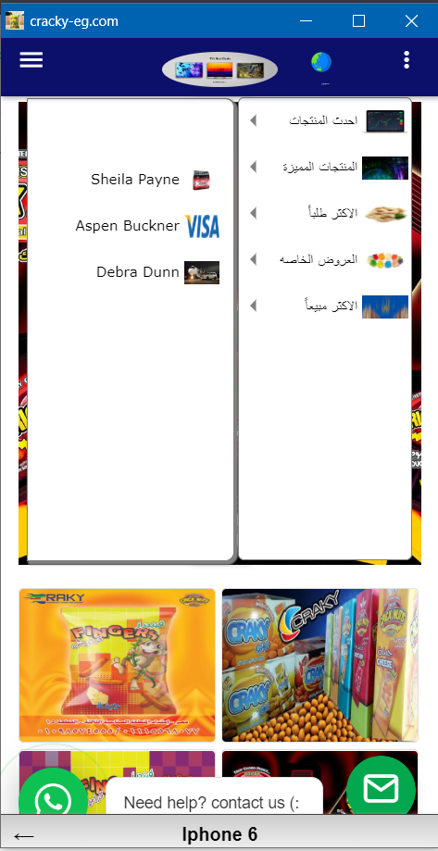



وده مكان ال ال plugin كله زى ما احنا متعودين انى احنا بنخلى كل plugin لى وحده

